**Retail Sales Data Analysis and Dashboard Creation**

SUBMITTED BY:

Shreeram.K

REG. NO:

2463057

COLLEGE EMAIL ID:

[Shreeram.k@btech.christuniversity,in](mailto:Shreeram.k@btech.christuniversity,in)

Course:

Fundamental Data Analysis

INSTRUCTOR’S NAME:

Diraj Alate

INSTITUTION:

Christ University Kengeri

DATE OF SUBMISSION:

19/9/2025

ABSTRACT:

This project performs an exploratory data analysis on the 2022 FIFA World Cup Performance dataset for Argentina to uncover team contributions in terms of goals, assists, dribbles, and defensive actions. The key goal is to build a dynamic Excel dashboard that presents actionable insights into player performance and team dynamics. Microsoft Excel’s PivotTables and charts were used for data summarization and visualization. The final dashboard offers a clear view of team performance indicators such as goals, assists, dribbles, and tackles, supporting better understanding of team strengths.

OBJECTIVE:

* Clean and prepare the FIFA dataset for analysis.
* Formulate and answer five key performance questions based on the data.
* Create an interactive and user-friendly dashboard with relevant visualizations.
* Use appropriate charts and pivot tables and graphs and slicers to communicate insights clearly.
* Summarize findings and their implications for player and team strategy.

SCOPE OF THE PROJECT:

* Focused on data cleaning, exploratory analysis, and dashboard visualization only.
* No programming or advanced statistical modeling was used.
* All work was performed in Microsoft Excel within a single file.
* Analysis limited to the provided Argentina FIFA dataset.

TOOLS AND TECHNOLOGIES USED:

|  |  |
| --- | --- |
| **TOOLS/ TECHNOLOGY** | **PURPOSE** |
| Microsoft Excel | Data manipulation, analysis, and dashboard creation |
| Slicers | Interactive filtering by player position, appearances, or performance metrics |
| PivotTables | Summarizing data |
| Charts & Graphs | Data visualization |

DATA CLEANING AND PREPERATION:

The original dataset contained player-level performance records with fields like Player Name, Position, Appearances, Goals Scored, Assists Provided, Dribbles per 90, Tackles per 90, and Duels Won per 90. Missing values were minimal and handled by removing incomplete rows. New calculated metrics such as **Total Goals** and **Average Dribbles per 90** were derived using PivotTables to enable performance-based analysis.

DASHBOARD DESIGN STRATEGY:

The dashboard was designed to provide quick insights into Argentina’s team performance:

* A bar chart visualizes **total goals and assists by player**, highlighting attacking contributions.
* A pie chart displays **distribution of goals among players** to show reliance on key individuals.
* Line charts for **average dribbles and tackles per 90** minutes give clarity on ball progression and defensive efficiency.
* Interactive slicers allow filtering by player position (Forwards, Midfielders, Defenders).
* The layout balances charts and pivot tables for clarity and ease of interpretation.

QUESTIONS AND SOLUTIONS

|  |  |  |
| --- | --- | --- |
| **Question** | **Analysis** | **Solution** |
| What is the total number of goals scored by Argentina in the dataset? | Used PivotTable to sum “Goals Scored” for all players. | 15 goals |
| Who is the top goal scorer? | Used PivotTable to rank players by “Goals Scored”. | |  | | --- | | Lionel Messi – 7 goals |  |  | | --- | |  | |
| |  | | --- | | How many total assists were provided by the team? |  |  | | --- | |  | | Summed “Assists Provided” across all players. | 11 assists |
| What is the average number of dribbles per 90 minutes across the squad? | Calculated mean of “Dribbles per 90 Min”. | 1.2 dribbles/90 |
| Which player had the highest tackles per 90 minutes? | Identified maximum value in “Tackles per 90 Min”. | **Marcos Acuña – 2.9 tackles/90** |

CHALLENGES FACED AND SOLUTIONS:

|  |  |
| --- | --- |
| Challenge | Solution |
| Understanding football-specific performance metrics like “dribbles per 90” and “duels won”. | Researched metric definitions from FIFA resources. |
| Formatting dashboard for sports performance rather than business sales. | Adjusted layout with player-centric visuals (bar charts, pie charts). |
| |  | | --- | | Managing detailed player statistics in Excel without clutter. |  |  | | --- | |  | | Used PivotTables with slicers to filter by category. |

OUTCOME

The project successfully provided key insights into Argentina’s World Cup performance, showing how goals, assists, and defensive contributions were distributed across the squad. The dashboard is a valuable tool for understanding team dynamics and player roles. Through this project, I improved my Excel skills, particularly in adapting PivotTables and visualization techniques for sports analytics.

SCREENSHOTS OF FINAL OUTPUT

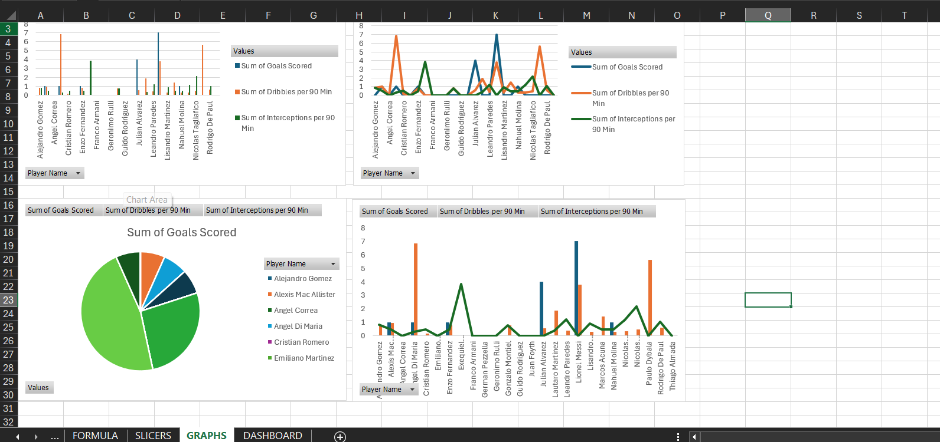

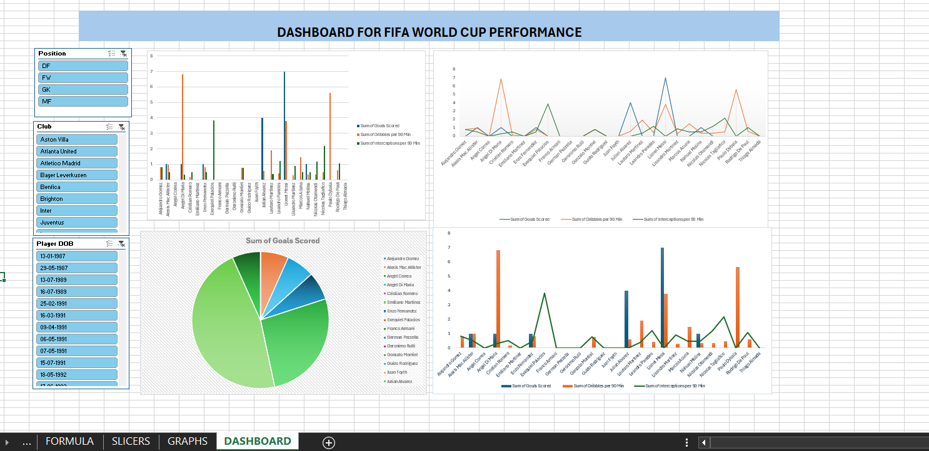

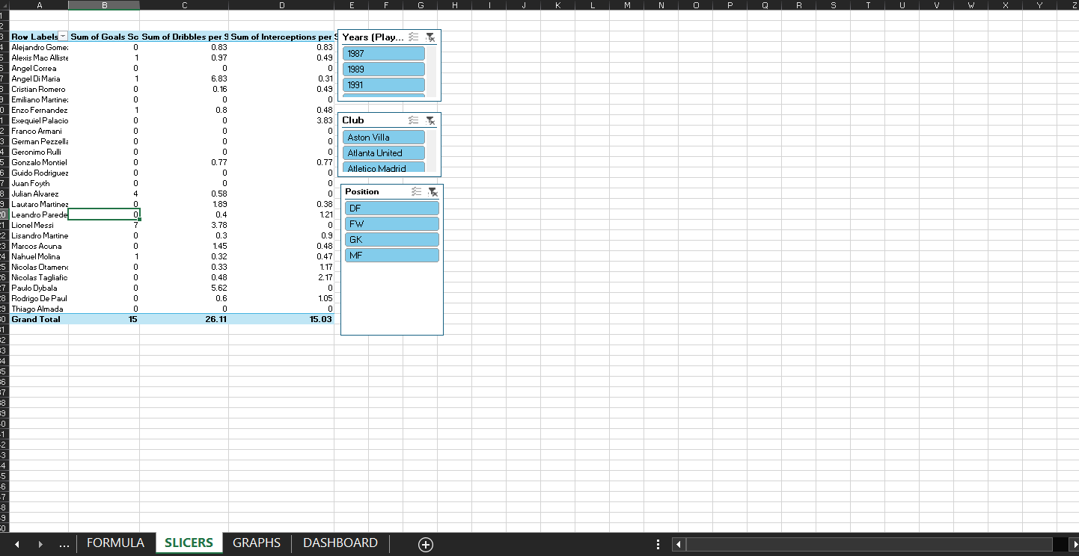

CONCLUSION:

This project strengthened my practical skills in Microsoft Excel for performance-based data analysis. Working with FIFA World Cup data taught me how to clean player datasets, use PivotTables effectively, and present sports insights visually. These skills will be valuable in future analytics tasks, whether in business or sports.

REFERENCES:

* FIFA Official Statistics (World Cup 2022 – Argentina Squad)
* Microsoft Excel tutorials on PivotTables and charts
* Sports analytics resources on football metrics (dribbles, tackles, duels)